**Unlocking Insights Into The Global Air Transportation Network With Tableau**

**1 INTRODUCTION**

**1.1 Overview:**

'Unlocking insights into the global air transportation network with Tableau involves collecting, integrating, and visualizing data from various sources to create interactive dashboards and reports. Through key metrics, geospatial analysis, time series analysis, network analysis, and customer segmentation, this approach provides a comprehensive understanding of the industry's dynamics. Predictive analytics helps forecast trends, while business intelligence tools allow for real-time monitoring and reporting. Continual updates and adaptation ensure that decision-makers have the most current information for optimizing operations, enhancing customer experiences, and addressing the evolving challenges within the aviation sector.

**1.2 Purpose:**

Unlocking insights into the global air transportation network, commonly achieved using data visualization tools like Tableau, serves the common purpose of improving the efficiency, safety, and sustainability of air travel. By analyzing data related to flight routes, passenger numbers, cargo volumes, and more, stakeholders can optimize operations, enhance safety, meet demand, reduce environmental impact, inform policy decisions, and ultimately provide a better passenger experience. These insights not only benefit airlines and airports but also support economic growth and global connectivity, making air transportation an essential component of modern society.

**2 PROBLEM DEFINITION AND DESIGN THINKING**

**2.1 Empathy Map**

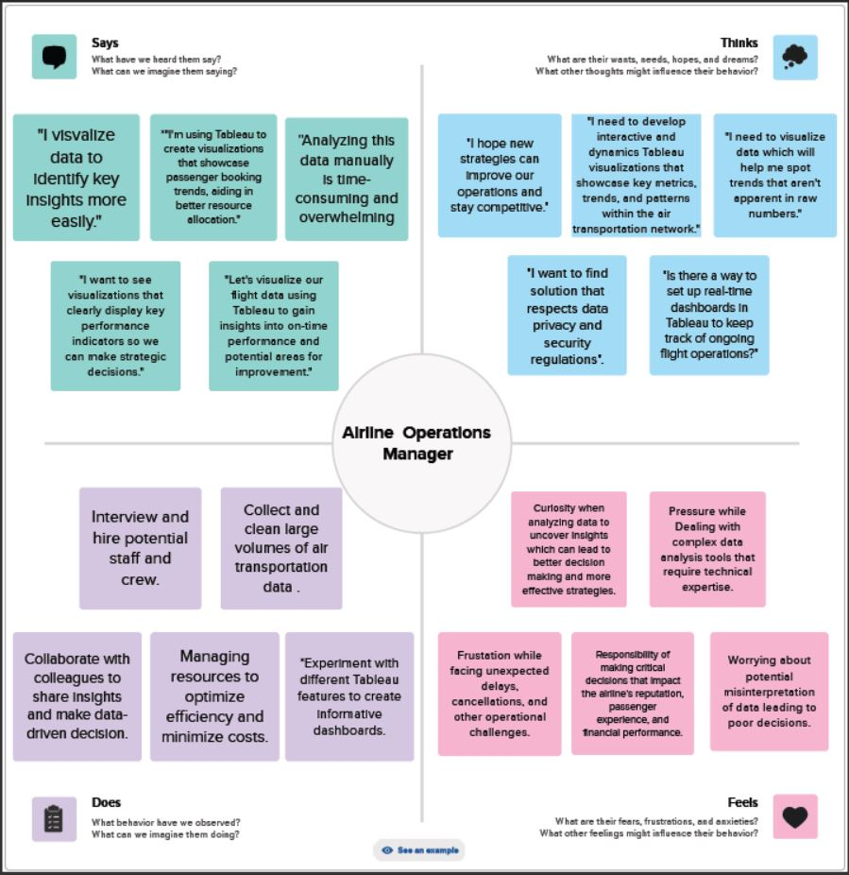

**2.2 Ideation and Brainstorming Map**

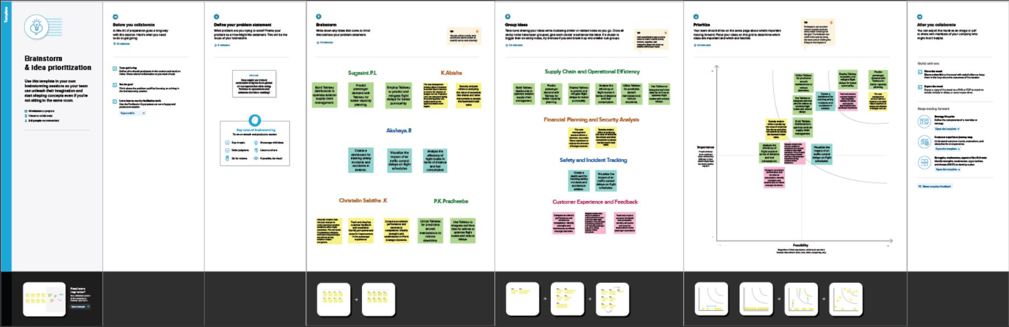

**3 RESULT**

Using dataset provided we created data visualizations like dashboards and story.

**DASHBOARD 1:**

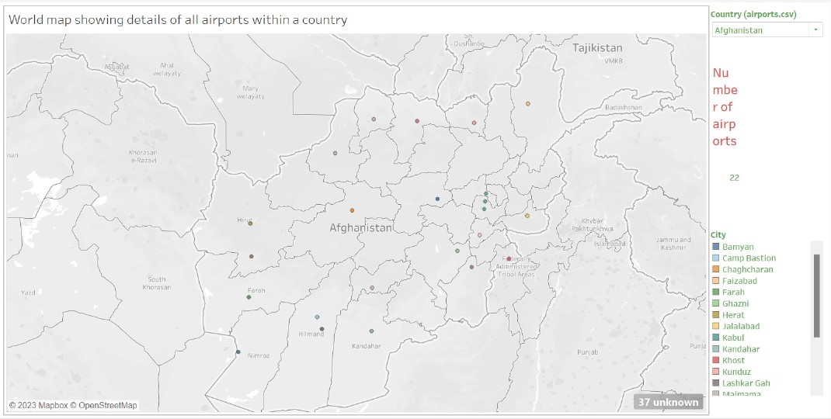

**DASHBOARD 2:**

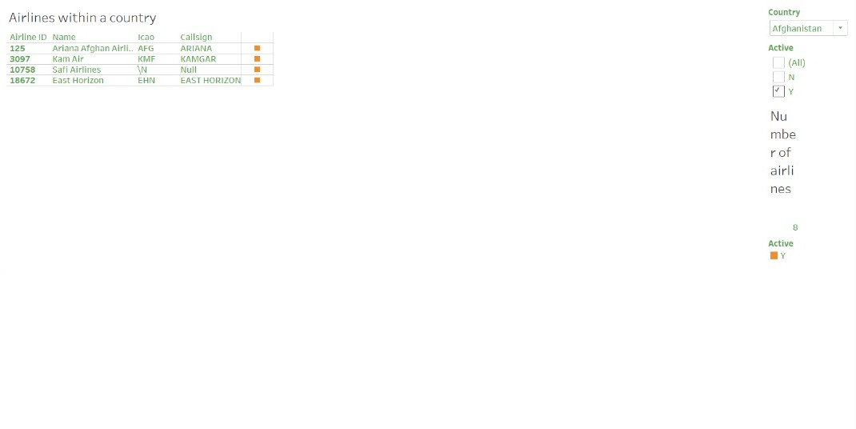

**DASHBOARD 3:**

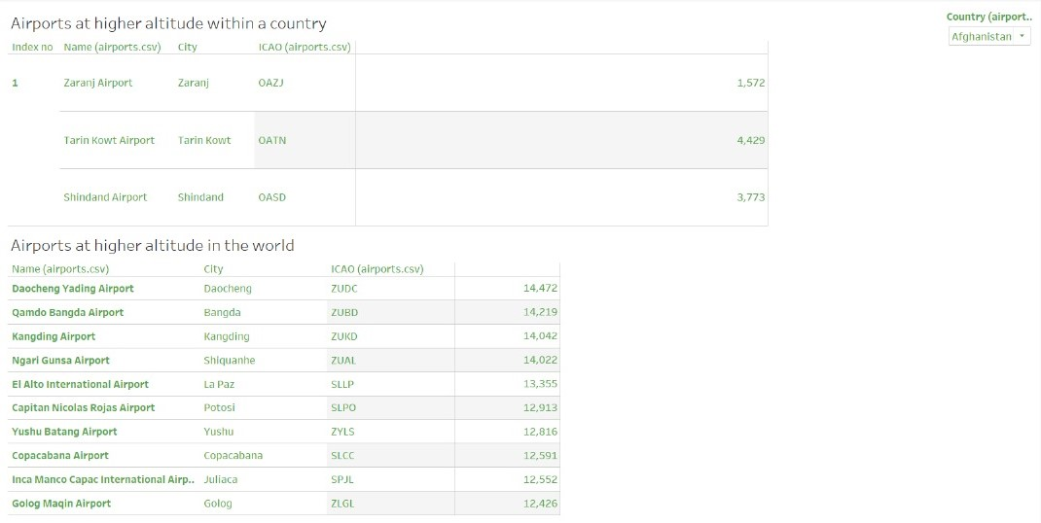

**DASHBOARD 4:**

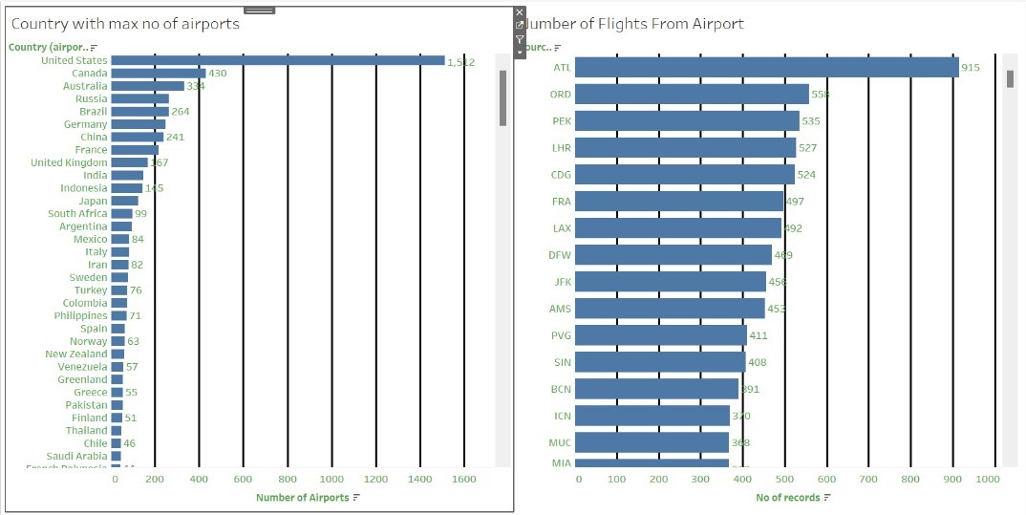

**STORY:**

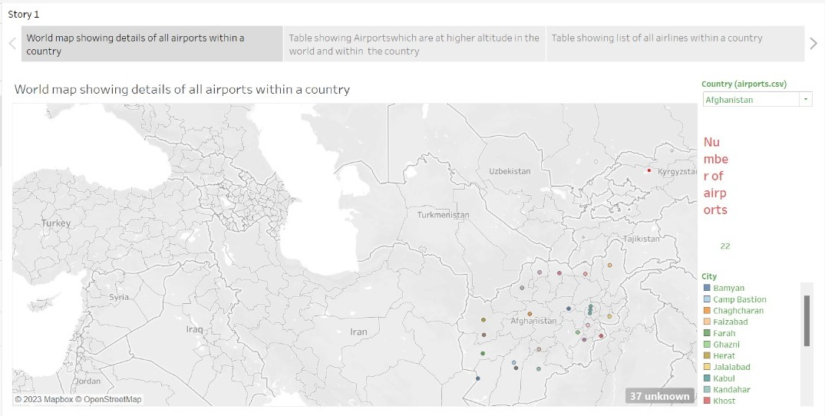

**4 ADVANTAGES AND DISADVANTAGES**

**Advantages:**

* Data-driven insights can lead to more efficient scheduling, resource allocation, and route planning, reducing operational costs for airlines and airports.
* Analysis can identify safety concerns and help implement measures to enhance safety standards, reducing accidents and incidents.
* Insights foster international trade, tourism, and cultural exchange, connecting people and businesses worldwide.
* Optimized operations can reduce fuel consumption and greenhouse gas emissions, contributing to environmental sustainability.
* Informed decisions can support economic growth and job creation, making the air transportation industry a significant contributor to GDP.

**Disadvantages:**

* Handling large volumes of data raises concerns about privacy and security, especially with sensitive passenger information.
* The accuracy and reliability of the data used for analysis can be a challenge, leading to potentially flawed insights.
* Collecting and processing data, as well as implementing data analysis tools like Tableau, can be costly and complex.
* Meeting privacy and data protection regulations can be challenging, especially in a global industry with different legal frameworks.
* Implementing insights may face resistance from traditional practices or stakeholders who are reluctant to embrace data- driven decision-making.

**5 APPLICATIONS**

The applications of unlocking insights into the global air transportation network are diverse and span various sectors and stakeholders. Here are some key applications:

* Efficiently allocate resources such as aircraft and crew based on demand patterns.
* Implement security measures based on insights to reduce vulnerabilities.
* Provide passengers with real-time updates on flight statuses and delays.
* Develop regulations and policies that enhance aviation safety and sustainability.
* Use insights to manage flights during natural disasters and emergencies.
* Investigate and prevent accidents by analyzing historical data.

**6 CONCLUSION**

* Define Problem / Problem Understanding
  + Specify the business problem
  + Business requirements
  + Literature Survey
* Data Collection & Extraction
  + Collect the dataset
  + Connect Dataset with Tableau
* Data Preparation
  + Prepare the Data for Visualization
* Data Visualizations
  + No of Unique Visualizations
* Dashboard
  + Responsive and Design of Dashboard
* Story
  + No of Scenes of Story
* Performance Testing
  + Utilization of Data Filters
  + No of Visualizations/ Graphs
* Publishing
  + Publishing Dashboard & Story to Tableau Public
* Project Demonstration & Documentation
  + Record explanation Video for project end to end solution
  + Project Documentation-Step by step project development procedure

**7 FUTURE SCOPE:**

The future scope of unlocking insights into the global air transportation network is marked by a growing reliance on advanced technologies, including AI and IoT, which will enhance operational efficiency, safety, and sustainability. It will enable personalized passenger experiences, optimized resource allocation, and greater focus on eco-friendly operations to reduce carbon emissions. The integration of emerging technologies like block chain and quantum computing will enhance data security and analytics. Furthermore, insights will extend beyond Earth's atmosphere, managing space travel, while fostering global collaboration and efficient crisis management. Data-driven insights will continue to play a pivotal role in shaping the aviation industry, making it more efficient, secure, and environmentally responsible while providing passengers with a more tailored travel experience.